CHAPTER 4: Ecosystems
Worksheet 4.3

Ocean explorations
Science Quest 7: pages 122–127
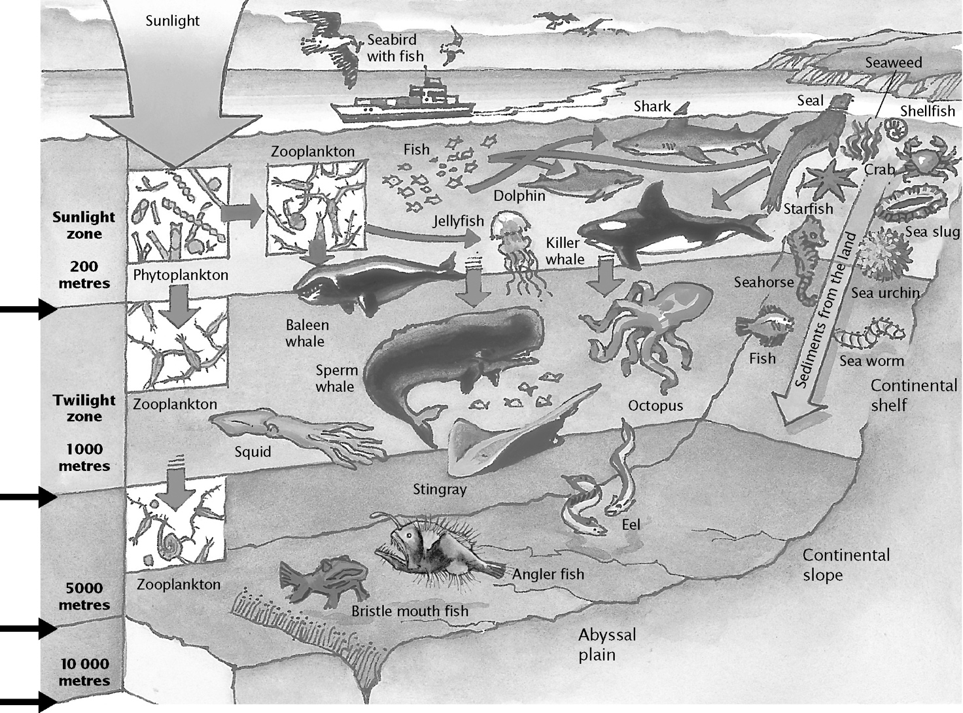
Student: Class:
3°C
3°C
22°C
6°C
A huge variety of amazing creatures live in our oceans. Imagine you have been invited on board a submersible craft that is capable of exploring the sea floor thousands of metres below the ocean surface. As you descend, what changes will you observe in the animals and plants that inhabit the ocean? Using the diagram above as a guide, write a brief description of how the plants and animals change along your journey to the seabed. Think about the size, shape, colour and variety of organisms at different depths. Write your descriptions in the table.

Changes observed in animals

CHAPTER 4: Ecosystems PAGE 2
Worksheet 4.3

Changes observed in plants

Now consider the non-living parts of the
ocean — light, temperature, water pressure and available oxygen. On the set of axes below, draw a graph that describes each of the non-living parts in the ocean and how they change at different depths. (Use the information in the diagram on the first page of this worksheet to help you.) Use different coloured lines for each non-living item described by the graph. Fill in the key. Predict how each factor will change at a depth of
12 000 m by using a pencil to continue each line.
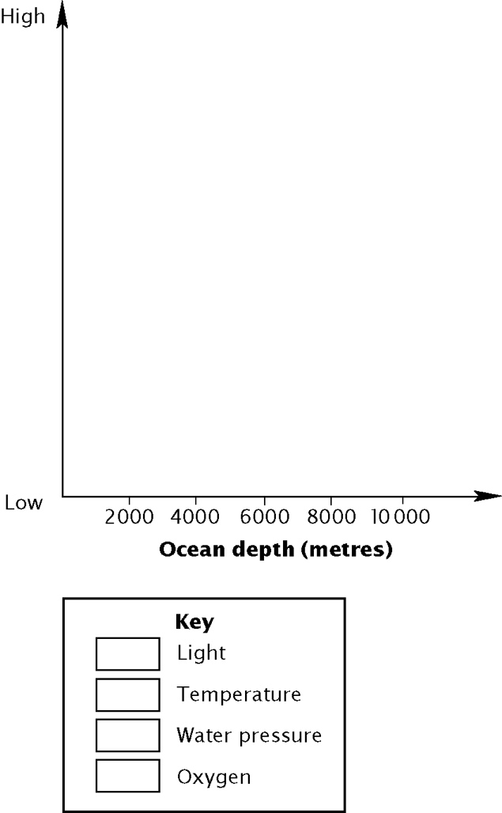
- Devise a coloured key for your graph.
Imagine you are a sea creature.
(a) What problems would you have living at the bottom of the ocean?

(b) What special features do you have that enable you to live at these amazing depths?

(c) Draw a portrait of yourself in the space below. Label your special features.

